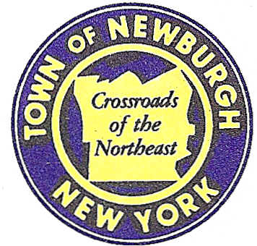

TOWN OF NEWBURGH
_______Crossroads of the Northeast __________________________
OLD TOWN HALL
308 GARDNERTOWN ROAD NEWBURGH, NEW YORK 12550

PLANNING BOARD
JOHN P. EWASUTYN, CHAIRMAN
TELEPHONE 845-564-7804
FAX 845-564-7802
E-MAIL: planningboard@townofnewburgh.org

PLANNING BOARD AGENDA

June 15th, 2017

*PLEASE NOTE: The Planning Board Meeting will start at 7:00 P.M. and all Applicants/Representatives
are to be present at that time. The Meeting will be held in the Meeting Room of Town Hall,
located at 1496 Route 300, Newburgh NY.*

1. The Ridge (f/k/a The Loop) (17-01) 6th AMENDED SITE PLAN
Rt. 300 & Rt. 52
Section, Block, Lot: Multiple Lots
Zone: IB & R-3
Rep: Divney Tung Schwalbe, LLP
1 North Broadway
White Plains, NY 10601

2. RAM Hotels, Inc. (16-21) SITE PLAN
Unity Place
Section 97, Block 2, Lot 37
Zone: IB
Rep: Mecurio-Norton-Tarolli- Marshall
45 Main St. PO Box 166
Pine Bush, NY 12566

3. Gardner Ridge (2002-29) SITE PLAN
Gardnertown Road near Gidney Avenue MULTI FAMILY
Section 75, Block 1, Lot 4.12
Zone: R-3
Rep: Darren Doce, P.E.
Doce Associates
5020 Route 9W, #19
Newburgh, NY 12550

*WORK SESSION*
Project Readiness Discussion scheduled for 5:30 p.m. in the Meeting Room of
Town Hall on Thursday, June 15th, 2017.*

4. Orange County-Pok LP d/b/a Verizon Wireless (2017-15) PUBLIC HEARING
181 South Plank Rd.
Section 60, Block 3, Lot 14.1
Zone: B
Rep: Young/Somer
Five Palisades Drive
Albany, NY 12205

PLANNING BOARD BUSINESS
WORK SESSION

*WORK SESSION*
Project Readiness Discussion scheduled for 5:30 p.m. in the Meeting Room of
Town Hall on Thursday, June 15th, 2017.*

